Minor Project  
Smoke Detection and Fire Prevention system using Cisco Packet Tracer

By Aniket Bandral, Tanisha Gandhi, Ritik Kotwal , Nitish Arora

# Placeholder image

# ABSTRACT

Smart home automation is a technology to make things happen at home automatically. When we say home automation, the first thing that comes to mind is robots, lighting, complex electronics, and a general feeling that it is a controlled warm, or cold condition of the home. However, some simple forms of automation such as Garage door opener, Remote controls, Irrigation/sprinkler control systems, Motion-activated lights, security systems. The home automation will have become important roles t in the human’s environment because it provides the users with comfort and calm for applying the home automation device. The design and implementation of smart home automation control uses three methods; Power Electrical system, fire alarm system, and home automation system to control the selective and security of the home device that protects the home. All of the systems are controlled by a server that is also called a registration server. Some devices used WIFI or WLAN and some of the devices that were used were wired (RJ45) or fiber optic.

# INTRODUCTION

Home fire detection is a matter of great concern, and thus many efforts are devoted in most developed countries to the design of automatic detection systems. A fire prevention system should reliably and in a timely way notify building occupants about the presence of fire indicators, such as smoke or high temperatures. A fire detector is usually implemented as a smoke sensor due to its early fire detection capability, fast response time, and relatively low cost. Other options for fire detection are based on gas sensors or temperature sensors fire detectors that use a single sensor, generally a smoke sensor and present high false-siren rates due to temperature.

# 

# Overview of Internet of Things

The Internet of Things (IoT) is a fast growing network and progress in it has created a new dimension in the world of information and communication technologies. It enables humans to control things smoothly and effectively, either from near or from a distance. The IoT represents anything that has an IP address in which it can communicate over the network; any physical object can be converted into an IoT device connected to the internet, including living organisms such as humans and animals, by adding sensors or actuators. For example, a person with wearable health monitors, Fitbit for cows, various household items, driverless cars, shipping containers and logistics tracking etc. The IoT device can be as light as a children’s toy or as serious as an airplane. One thing itself may contain multiple IoT components, such as a jet engine equipped with thousands of sensors. In short, the Internet of Things network is an advanced concept of the Internet network so that all things in our life (of various types, shapes and sizes) possess the ability to connect to the Internet or communicate with each other to collect data and share it to perform specific functions. Kevin Ashton defines IoT as “The Internet of Things’ means sensors connected to the Internet and behaving in an Internet-like way by making open, ad hoc connections, sharing data freely and allowing unexpected applications, so computers can understand the world around them and become humanity’s nervous system”.

# PROPOSED SMART HOME SYSTEM AND ARCHITECTURE

In this paper, we explained how smart home was implemented through the simulation framework based on the Cisco packet tracer version 7.3.0. Cisco Packet Tracer is a tough Cisco system Academy network modeling application which can simulate/create a network without a physical network. It has a drag and drop interface that is easy to use while configuring complex networks . Along with the various classical network devices available in the previous versions, Packet Tracer version 7.0.0 received an important upgrade with Smart objects and IoT components. Additionally, Cisco Packet Tracer (version 7.2) can operate as a hybrid network that combines real networks with virtual networks [18]. This latest version of cisco packet tracer (7.2) is also added to MCU-PT board single boarded computers (SBC-PT), offering programming environment to power connected devices. Newly released Packet Tracer advantages are [6]: Provides the practical IoT machine simulations and visualizations. Allows users to plan, create, customize smart homes, smart cities by supplying them with various smart objects. Provide board for the control of intelligent objects. Allow students to explore the concepts of IoE principles. Provide sensor detector. Cisco packet tracer included different smart objects used for home automation such as chic windows, chic fans, chic lights, chic doors, chic garbage doors, lawn sprinklers, fire sprinklers, web cams and various sensors.

The Microcontroller (MCU-PT) and Home Gateway are used for controlling the objects and sensors, since it provides a programming environment for controlling objects connected to it and provide controlling mechanisms by registering smart devices to Home Gateway respectively. To implement a smart home using Cisco packet tracer, we used different sensors, smart devices and detectors to make it smarter.

**Figures (1 and 2) represent the home architecture that connected each other using wireless and wired medium. The Figures from (3 to 6) represent the Home Gateway and IoT device Settings. Figure 7 shows the main IoT Homepage.**

[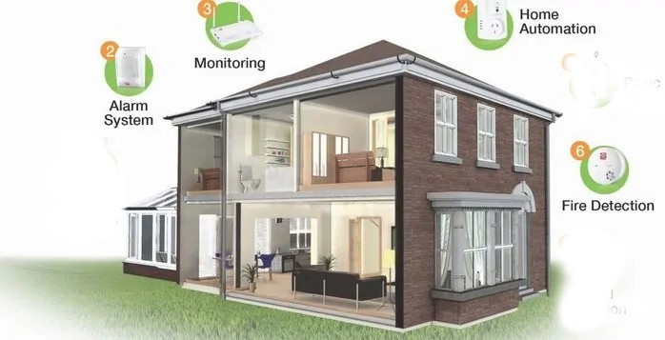](https://www.cpvansmart.com/wp-content/uploads/2020/04/Cpvan-smart-lighting3-1-700x360.jpg.webp)

**Figure 1** Smart Home architecture on physical workspace when IoT devices status OFF, where IoT devices have been placed in the appropriate position in the house to suit the needs of the home residents and according to the proposed design

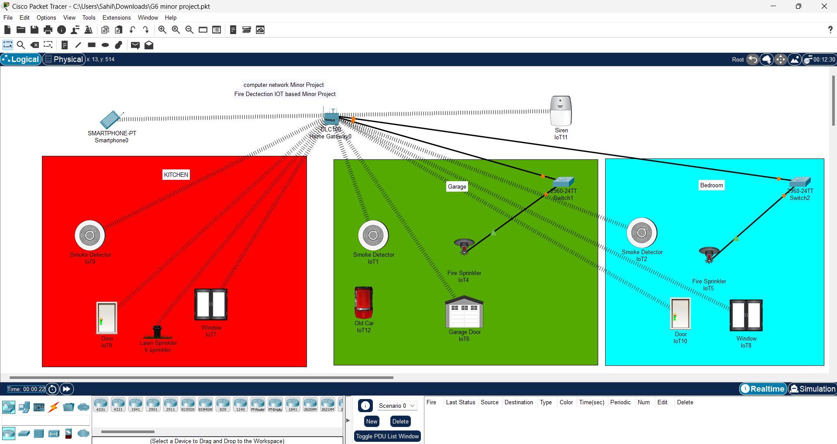

**Figure 2** Smart Home architecture in logical Workspace when IoT devices status ON. As shown, all IoT devices are wirelessly connected to the Home Gateway

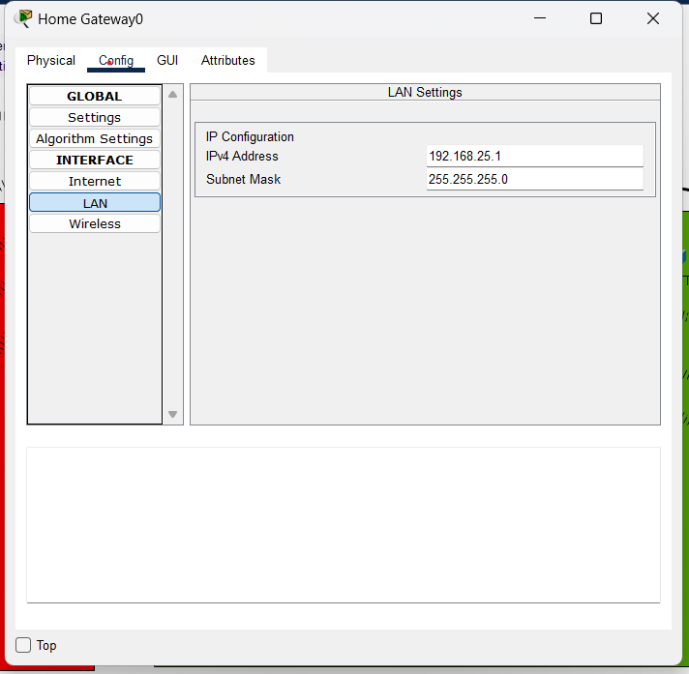

**Figure 3** Home Gateway Settings

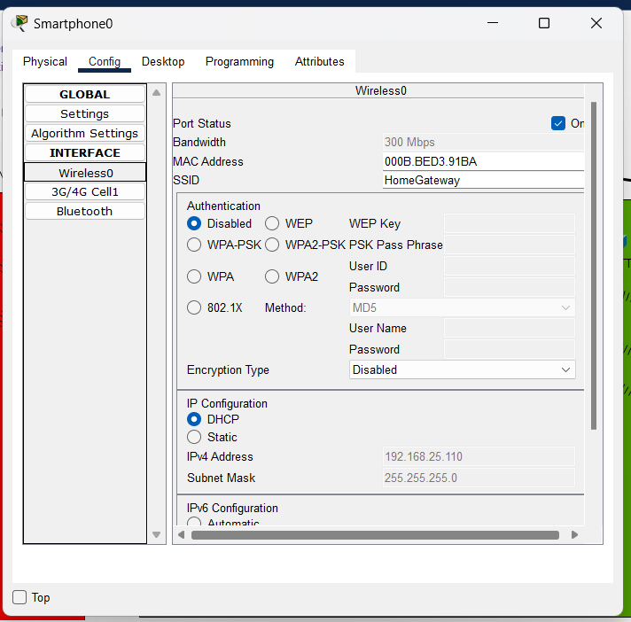

**Figure 4** Registering IoT Device to Home Gateway



**Figure 5** Configure Wireless Settings for the IoT Device

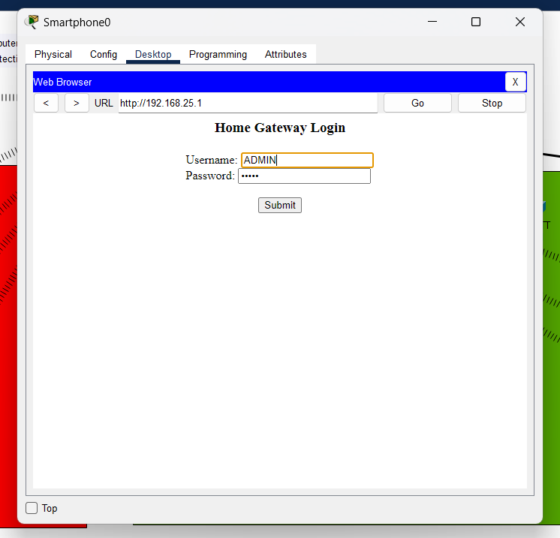

**Figure 6** Login to the IoT Homepage from Smart Phone

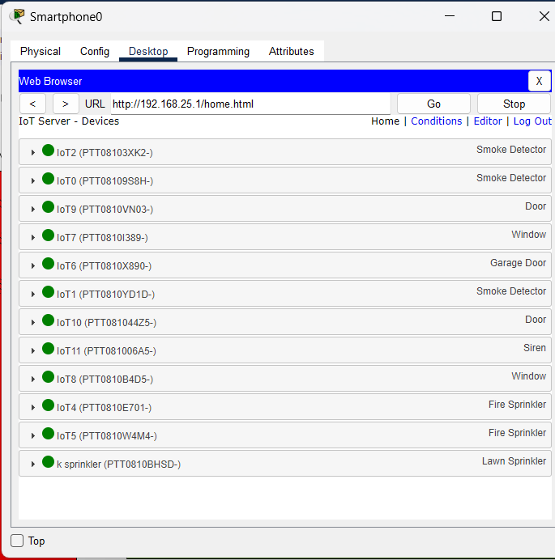

**Figure 7** IoT Homepage from the Smartphone to check the status and monitor the list of all connected IoT devices; and the figure shows also,

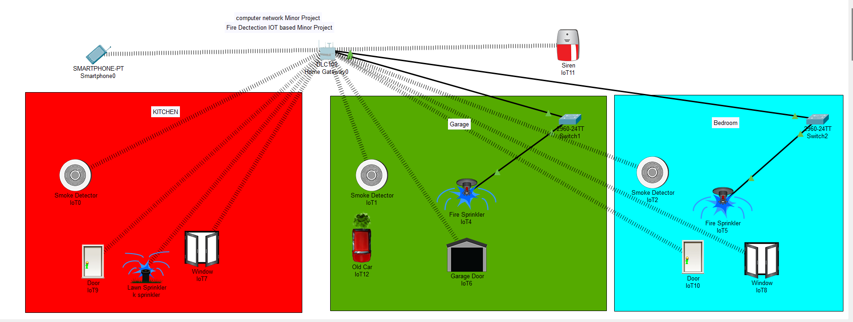

**Figure 8**  the case when smoke or fire were detected by sensor all devices that are connected with home gateway get activated.

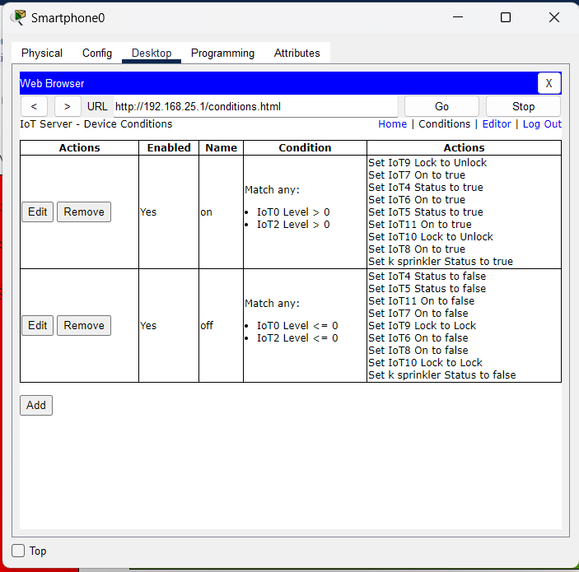

**Figure 9** Pre-set conditions from Smart Home Owner made on Home Gateway to control IOT Device



As shown in Figure a car was used, smart garage door, motion detector, carbon monoxide alarm, but the car was used only to affect the environmental variable of the simulation as a carbon monoxide increase. For this case, when the CO level > 0% alarm is turned on,In fire sprinkler system. Table 1 shows the devices and machines used for design.

# TABLE I: DEVICES AND MACHINES USED FOR DESIGN

| **No.** | **Device or Function Machine** | **Function** |
| --- | --- | --- |
| **1** | **Smart Phone** | **Connect to home getaway to access smart object** |
| **2** | **Home Gateway** | **Used to register smart object and give IP address to it, then you can remotely managed through a web interface hosted** |
| **3** | **Fire monitor** | **Detect IR in the range of fire** |
| **4** | **Fire Sprinkler** | **A Sprinkler that puts out fire** |
| **5** | **Siren** | **Provide sound for event on the trip sensor** |
| **6** | **Smart door** | **Connect to home getaway and provide Function based event** |
| **7** | **Old car** | **Used to change the Carbon Monoxide level, Carbon Dioxide and smoke level** |
| **8** | **Garage Door** | **Automatically opens when there is smoke or fire detection** |
| **9** | **Switches** | **Used to connect iot devices with home gateway** |

# 4. CONCLUSION

The idea of the proposed model of smart home can support many home automation systems. The smart home includes a connection between wireless communication, sensors, monitoring and tracking devices. Smart homes are a huge system that includes multiple technologies and applications that can be used to provide easy home security and control. The proposed system discussed the designed modules such as sensor circuits, home monitoring.

# 

# 5. REFERENCES

<https://www.youtube.com/watch?v=PYqIvoPEmRA>

<https://amity.edu/UserFiles/aijem/1391.pdf>

https://www.cpvansmart.com/wp-content/uploads/2020/04/Cpvan-smart-lighting3-1-700x360.jpg.webp